MP Online AIML Assignment

Name: Yash Diwan
Registration No: 23BCE10154
Adult Census Income Dataset
The dataset contains demographic and employment-relate information and the target variable is whether an individual's incom exceeds $50,000 per year.

Algorithm | Accuracy | Precision | Recall | F1 Score | ROC - AUC
Logistic Regression | 0.8267 | 0.6800 | 0.5300 | 0.5957 | 0.8737
Decision Tree | 0.8254 | 0.6513 | 0.5931 | 0.6208 | 0.8504
Random Forest | 0.8231 | 0.6512 | 0.5727 | 0.6094 | 0.8645
KNN | 0.8161 | 0.6318 | 0.5670 | 0.5976 | 0.8392
SVM | 0.8245 | 0.7025 | 0.4713 | 0.5641 | 0.8499

Task 1: Dataset Understanding (10 Marks)
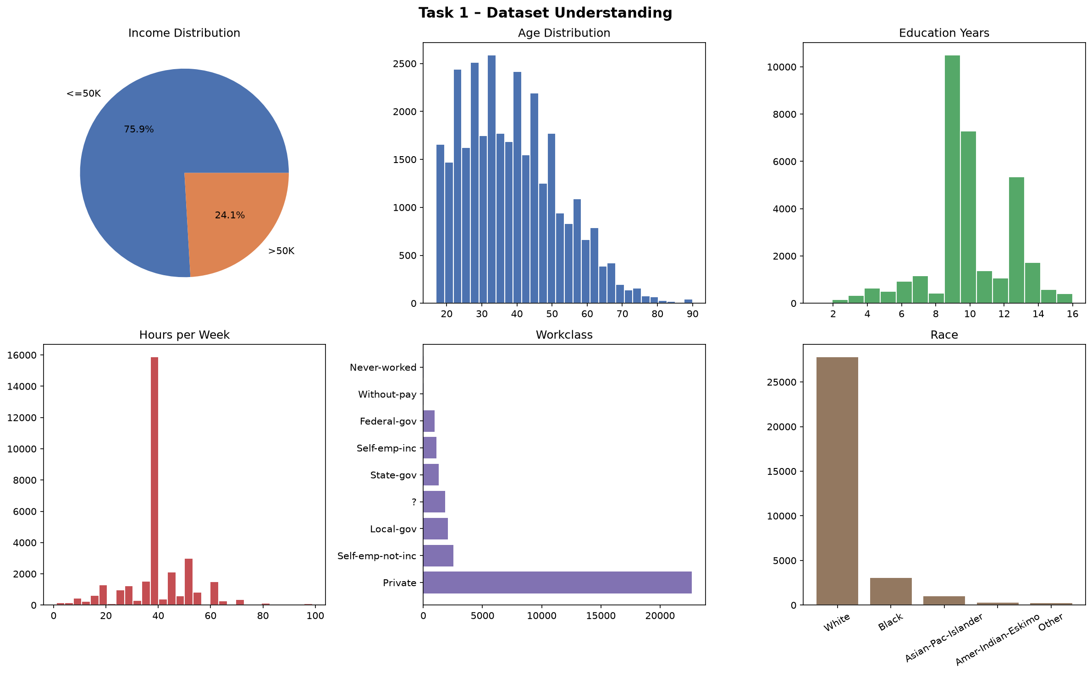
Task 2: Data Cleaning (20 Marks)
In this phase, the dataset was cleaned to ensure data quality prior to modeling:
- Missing Values: Missing placeholders (?) were replaced with NaN. Categorical missing values were imputed using the column's most frequent value (mode).
- Formatting & Duplicates: Leading and trailing whitespaces were stripped from text columns, and all duplicate rows were removed.
- Outliers: Extreme values in numerical columns (like age and capital-gain) were capped using the Interquartile Range (IQR) method to prevent them from skewing the models.
Task 3: Feature Engineering (15 Marks)
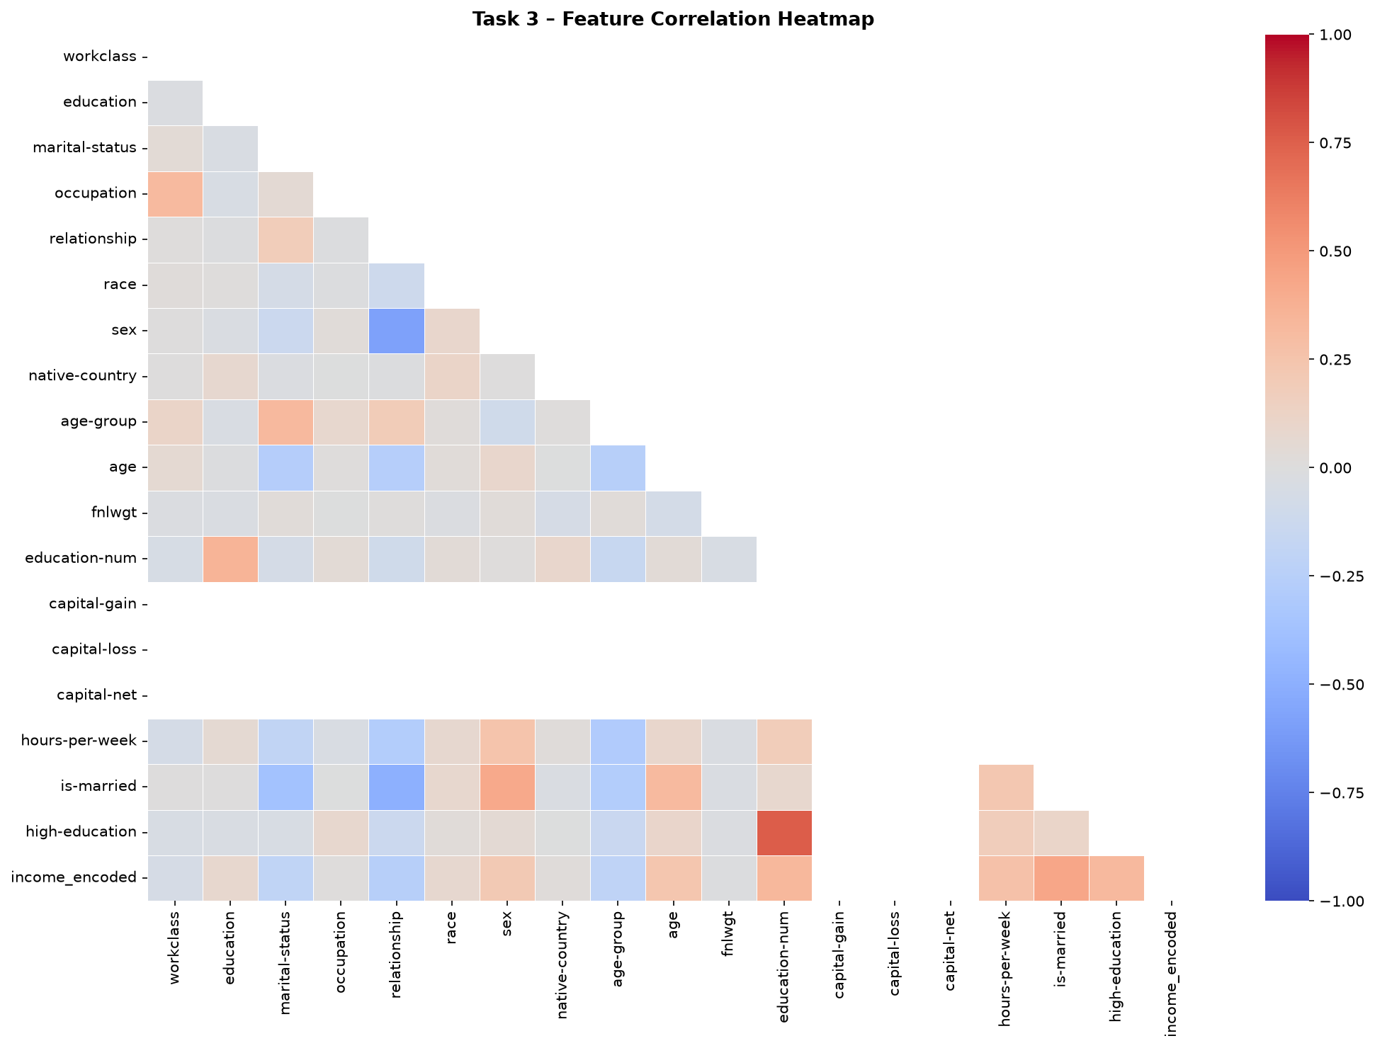
Task 4: Model Building (30 Marks) Classification Algorithms
We trained multiple classification models to predict the income brackets:
- Data Splitting & Scaling: The dataset was split into an 80% training set and a 20% testing set using stratification to maintain class balance. Numerical features were standardized using StandardScaler for distance-based models.
- Algorithms Used: Five models were built and trained:
  - Logistic Regression (baseline linear model)
  - Decision Tree (max depth limited to 10 to prevent overfitting)
  - Random Forest (ensemble of 100 trees for robustness)
  - K-Nearest Neighbors (KNN with k=7)
  - Support Vector Machine (SVM with an RBF kernel for non-linear boundaries)
- Testing: Each trained model was used to predict classes and probabilities on the 20% test data, which were then saved for performance evaluation.

Task 5: Performance Evaluation (15 Marks)
